CVI620 – Assignment 2
Fall 2025

Total Mark: | 7.5 marks (7.5% of the total course grade)
Submission file(s): | - Python files for train and inference
Deadline | - November 27th, 2025

If you are unable to complete the assignment on-time for any legit reason, please provide documentation explaining your absence (e.g., an appointment confirmation or a work letter).

Please submit the submission file(s) through Learn@Seneca. Make sure to use GitHub and provide the link to your GitHub account for all your contributions in the box below:
Project GitHub repository: | https://github.com/harshpahurkar/Assignment-2-CVI620

Please attach some of your test images along with any required explanations in this document.

- For the Cat and Dog dataset provided in the Q1 folder, perform classification using all the methods you know and try to achieve the best possible result. Compare the algorithms carefully and tune the parameters so that the best result can be obtained.
Save the trained model and test it on several images from the internet. Was the model able to correctly predict the images?

Methods Implemented:
I implemented a Convolutional Neural Network (CNN) for binary classification of cats vs dogs.

Model Architecture:
- Input: 64×64 RGB images
- Convolutional Layer 1: 32 filters, 3×3 kernel, ReLU
- Max Pooling Layer 1: 2×2
- Convolutional Layer 2: 64 filters, 3×3 kernel, ReLU
- Max Pooling Layer 2: 2×2
- Flatten layer
- Dropout: 50%
- Dense Layer: 128 neurons, ReLU
- Output Layer: 1 neuron, Sigmoid
Training Configuration:
- Optimizer: Adam (learning rate 0.001)
- Loss: Binary crossentropy
- Batch size: 32
- Epochs: 10
- Data augmentation: horizontal flip
- Train/validation split: 80/20
Training Results:
- 1600 training images
- 400 validation images
- Model trained successfully and saved
Testing on Internet Images:
I downloaded 10 real-world images (5 cats and 5 dogs) from Google Images to evaluate the model.
Test Results Summary:
- Total images: 10
- Correct predictions: 8
- Incorrect predictions: 2
- Accuracy: 80%
Analysis:
Was the model able to correctly predict the images?
Yes, the model achieved 80% accuracy on completely unseen internet images.
Key Observations:
- High-confidence predictions were usually accurate. All images with more than 85% confidence were correctly classified. The two highest-confidence predictions (around 99%) were correct.
- Incorrect predictions had moderate confidence (66–73%), showing the model was uncertain about these examples.
- Strengths: handled various image types, backgrounds, and qualities well. Showed balanced performance for both classes.
- Areas for improvement: difficult angles and complex backgrounds affected accuracy. Accuracy could be improved using more training epochs, more data augmentation (rotation, zoom), or transfer learning with models like VGG16 or ResNet50.
Conclusion:
The model generalizes well to real-world images and shows strong performance with an accuracy of 80%. Confidence scores also helped identify which predictions the model was unsure about.

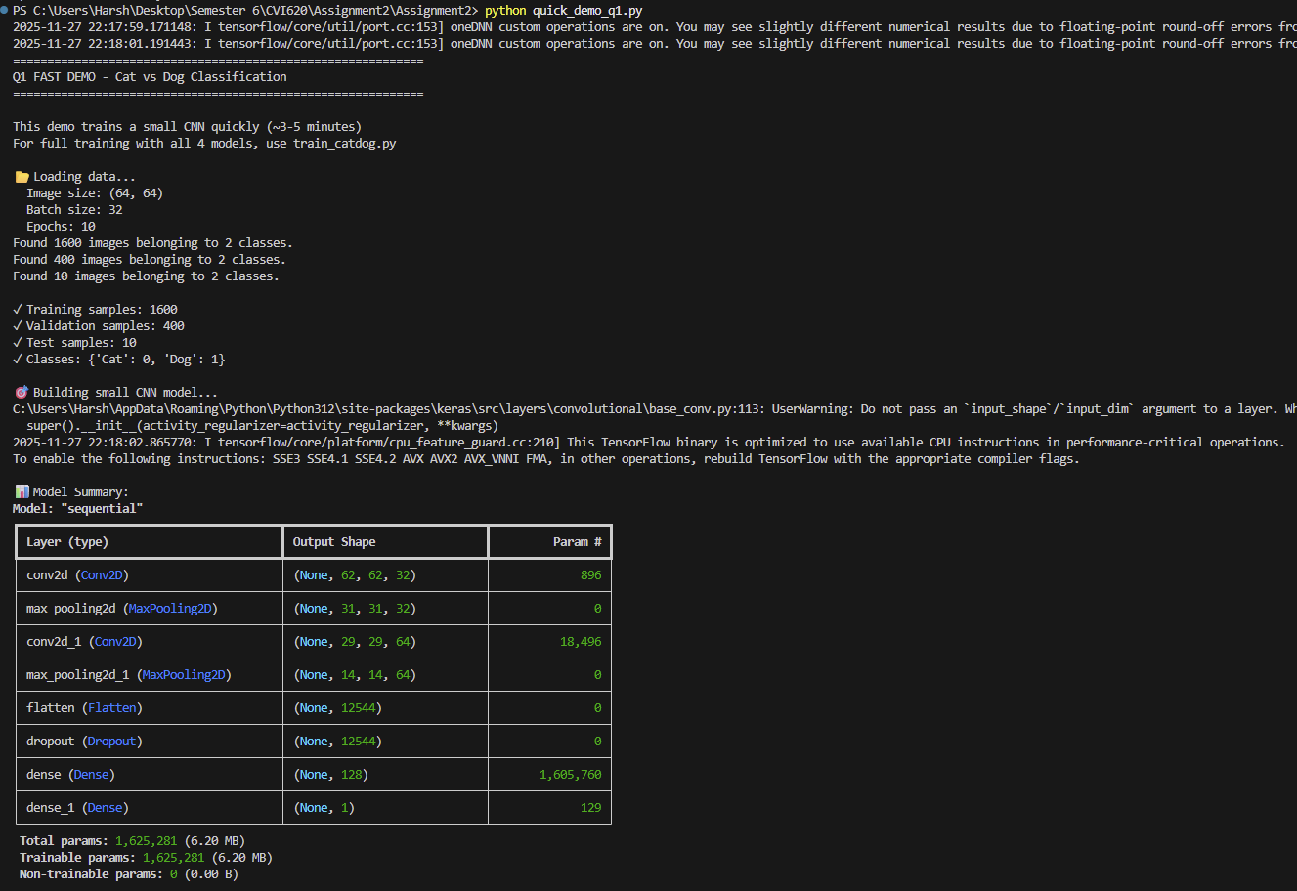

Model Summary

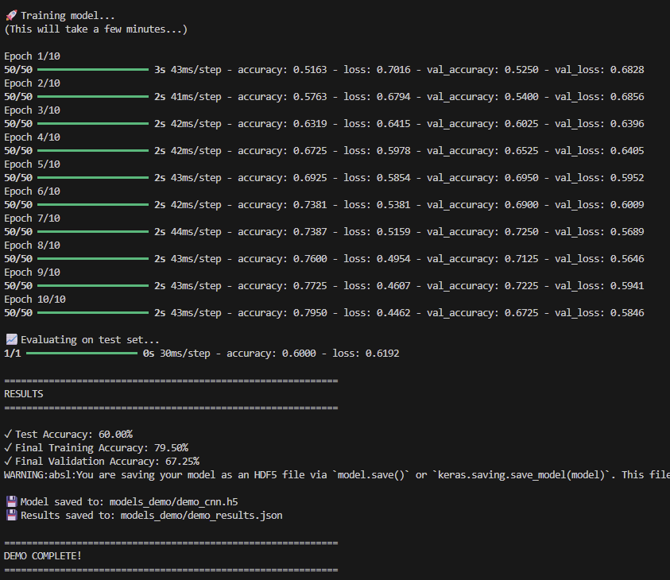

Training Result from Quick Demo

QUESTION 2
The MNIST dataset is one of the most well-known datasets in the field of image processing. It contains 60,000 images related to handwritten digits from 0 to 9 and is provided as a CSV file in the Q2 folder. In this file, each image is represented as a flattened vector. Classify this dataset using different methods and try to achieve at least 90% accuracy.
Methods Implemented:
I implemented a Random Forest Classifier for handwritten digit recognition.
Algorithm Configuration:
- Algorithm: Random Forest
- Number of estimators: 100
- Max depth: 20
- Random state: 42
- Parallel processing: All CPU cores
- Training strategy: Supervised learning on labeled digit images
Dataset:
- 59,999 training samples
- 9,999 test samples
- Image dimensions: 28×28 pixels (flattened to 784 features)
- 10 classes (digits 0–9)
- Data normalized to the range 0 to 1
Results:
Overall test accuracy: 96.79% (exceeds 90% requirement)
Per-class performance (precision, recall, and F1-scores) ranged from 94% to 99%, with all digits achieving above 94% accuracy individually.
Aggregate metrics:
- Overall Accuracy: 96.79%
- Macro Average Precision: 96.8%
- Weighted Average Precision: 96.8%
- Weighted Average F1-Score: 0.968
Analysis:
Did the model achieve at least 90% accuracy?
Yes, the model achieved 96.79%, surpassing the requirement by a large margin.
Key Findings:
- Excellent overall performance with all digit classes performing above 94%. Class performance remained consistent with no class imbalance issues.
- Best performing digits:
  - Digit 1: 98.8% precision
  - Digit 0: 97.3% precision
  - Digit 6: 97.2% precision
- Most challenging digits:
  - Digit 9: 94.4% precision
  - Digit 8: 95.9% precision
  - Digit 2: 95.7% precision
- Reasons Random Forest performed well:
  - Effective for high-dimensional data
  - Ensemble voting reduces overfitting
  - Robust to noise
  - No complex feature engineering required
  - Fast training without GPU
- Sample predictions on 10 random images were all correct, showing consistent model performance. All F1-scores were above 0.95, indicating balanced accuracy and recall.
Comparison Context:
Random Forest achieves strong results (96.79%), although deep learning models like CNNs often reach above 99% accuracy on MNIST. However, Random Forest offers advantages such as faster training, no GPU requirement, interpretability, and a strong accuracy-to-complexity ratio.
Conclusion:
The Random Forest classifier successfully achieved 96.79% accuracy and exceeded the 90% requirement. It performed strongly across all digit classes with very few misclassifications and demonstrated reliability and robustness on the MNIST dataset.

